**ENGR 4020 Lab 2 [15 pts]**

**Open Loop Motor Control**

**Demonstrate by 1/30/2020**

**Submit by 1/31/2020**

**Part 1**

Build the following circuit and demonstrate operation of following circuit for controlling a motor in two directions. The motor is controlled by flipping a switch to reverse change the direction of current passing through the motor.

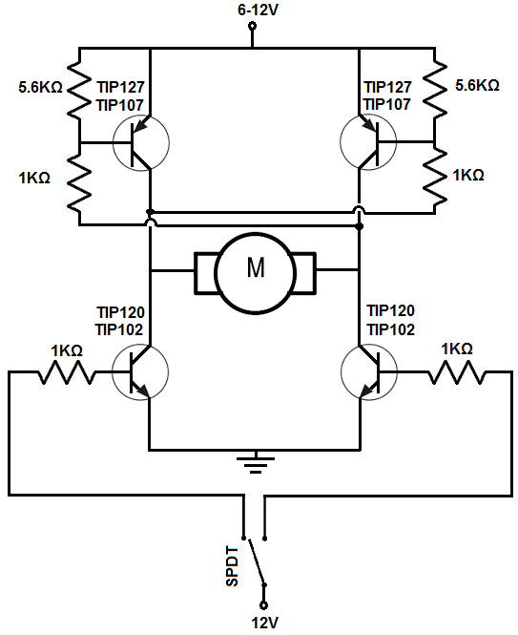

**Figure 1:** Single H- Bridge Circuit[1]

**Part 2**

On your robotic platform, write code to turn the robot according to the following table. You must use Pulse Width Modulation, and this should work for an average battery voltage of 6V. Note that a quick stop is implemented by setting the inputs to the H-Bridge to either all high or all low. These routines will be implemented using timing (wait functions). This is an example of open loop control: there is no measurement of actual angle of rotation. You should write a different program for each routine, but at the end of each routine you must write the values for QuickStop to the motors.

|  |  |
| --- | --- |
| **Routine Name** | **Description** |
| Left90 | Turn left 90 degrees at fast speed D>0.7 |
| Left90slow | Turn left 90 degrees at slow speed D<0.5 |
| Right90 | Turn right 90 degrees at fast speed D>0.7 |
| Right90slow | Turn right 90 degrees at slow speed D<0.5 |
| Left180 | Turn left 180 degrees at fast speed D>0.7 |
| Left180slow | Turn left 180 degrees at slow speed D<0.5 |
| Right180 | Turn right 180 degrees at fast speed D>0.7 |
| Right180slow | Turn right 180 degrees at slow speed D<0.5 |
| QuickStop | Quick stop (no spinning) |
| Forward | Drive forward straight (no natural curve) |

**Requirements**

1. Document this lab exercise in your lab notebook, including any circuits and code generated.
2. Demonstrate functionality of the discrete component H-Bridge to your instructor.
3. Submit your code as .cpp files on Canvas.

1. <http://www.learningaboutelectronics.com/Articles/H-bridge-circuit-with-transistors.php>